### 

Nazarbayev Intellectual School

Turkistan city

Aeroo Space Settlement Competition

Team Name: CELESTIALS👾

Category:Senior League

### Abstract

This project proposes the design of a toroidal space colony engineered to provide all essential conditions for sustainable long-term human habitation in outer space.

The toroidal configuration enables the generation of artificial gravity through controlled rotation, ensuring physiological adaptation, stable health conditions, and enhanced habitability for future settlers.

The settlement is supported by a network of autonomous robotic systems responsible for critical operations, including habitat maintenance, structural assembly, and agricultural management.

These systems function independently to ensure continuous operation, optimize resource utilization, and maintain environmental equilibrium within the closed ecosystem.

By integrating advanced life-support infrastructure, automation, and modular design principles, this concept establishes a scalable and self-sufficient model for human colonization beyond Earth, aligning with the long-term objectives of interplanetary and interstellar exploration.

### Table of Contents

1. Team Members……………………………………………………………………...
2. Introduction…………………………………………………………………………
3. Colony Description…………………………………………………………………

3.1. Residential Zone……………………………………………………………….

3.2. Industrial Zone…………………………………………………………………

3.3. Agricultural and Life Support Zone…………………………………………

3.4. Energy and Power Sector………………………………………………………

3.5. Docking and Transport Hub……………………………………………………

3.6. Control and Research Center…………………………………………………..

3.7. The schematics of our settlement………………………………………………

1. Orbit and Location………………………………………………………………….

4.1. Key features……………………………………………………………………

4.1.1. Gravitational stability and orbital mechanics………………………………

4.1.2. Sustainable and reliable solar energy………………………………………

4.2. Orbit short characteristics……………………………………………………...

1. Resource Extraction Plan…………………………………………………………...

5.1. Oxygen…………………………………………………………………………

5.2. Water…………………………………………………………………………...

1. Population and Society……………………………………………………………..

### 6.1. Total Population and Structure………………………………………………….

6.2. Reproductive Viability and Age Distribution…………………………………

6.3. Generational and Genetic Stability……………………………………………..

### 6.4. Occupational Distribution………………………………………………………

6.5. Environmental and Ecological Balance………………………………………...

6.6. Graphic of population growth…………………………………………………..

6.7. Cyborgs…………………………………………………………………………

6.7.1. Core Concept………………………………………………………………...

6.7.2. Long-Term Vision……………………………………………………………

1. Technology and Systems……………………………………………………………

### 7.1. AURIS…………………………………………………………………………

7.2. ARACHNOS…………………………………………………………………

7.3. VERDANT……………………………………………………………………..

7.4. Prototypes of robots……………………………………………………………

1. Sustainability and Longevity……………………………………………………….
2. Space Safety System Overview……………………………………………………

9.1. Detection and Tracking…………………………………………………………

9.2. Collision Avoidance…………………………………………………………….

9.3. Physical Protection……………………………………………………………...

1. Conclusion………………………………………………………………………….
2. Bibliography………………………………………………………………………..

### 1. Team Members

Umarov Samir: Project Coordinator

Tursynkhan Nurakhmet: Life & Society Designer

Yangibayev Gulamzhon: Automation & AI Specialist

Khabibullayev Shakhrukh: Data & Research Analyst

Abdulmannapov Dilnur: System & 3D Engineer

### 2 . Introduction

Living in space has always been one of humanity’s biggest dreams. As space travel becomes more advanced, scientists and engineers are looking for ways to build habitats where people can live permanently and safely. Current space stations are small and cannot fully support life for a long time without help from Earth

Our project presents a toroidal space station designed to make long-term life in space possible. Its circular shape creates artificial gravity through rotation and provides comfortable living conditions. The station includes life-support systems, energy sources, and autonomous robots that help with maintenance, construction, and food production. This project shows how technology and engineering can work together to make space settlement a real possibility for the future.

3. Colony Description

The toroidal space colony is a rotating ring-shaped structure designed to host a self-sustaining human settlement in orbit. The total diameter of the station is 1 kilometer, while the main living ring has a radius of 250 meters and a width of 100 meters. The slow and steady rotation of the structure creates artificial gravity of approximately 1 g along the outer edge, providing conditions similar to those on Earth.

The colony is divided into several specialized zones to maintain safety, efficiency, and sustainability. Each zone is separated by reinforced bulkheads and connected through pressurized transport tunnels and elevators located in the station’s spokes.

3.1 Residential Zone

•Located on the outer section of the ring where gravity is strongest.

•Contains living quarters, recreation areas, education centers, and medical facilities.

•Artificial day-night lighting cycles help maintain human circadian rhythms.

•Emergency shelters and life-support backups are integrated into the sector walls.

3.2 Industrial Zone

•Situated in a mid-ring sector closer to the central hub.

•Includes small-scale manufacturing facilities, material recycling plants, and maintenance workshops.

•Operated mainly by autonomous robots to minimize human exposure to hazardous materials.

•Waste from other sectors is processed here for reuse (closed-loop resource system).

3.3 Agricultural and Life Support Zone

•Located opposite the industrial zone to ensure clean air circulation.

•Equipped with hydroponic and aeroponic farms, algae tanks for oxygen production, and water purification systems.

•Maintained by verdant agricultural robots that monitor plant growth and optimize environmental conditions.

3.4. Energy and Power Sector

•External layer with arrays of solar panels and radiation shields.

•Energy is stored in modular battery units and distributed through superconductive conduits.

•Backup nuclear microreactor ensures continuous power during eclipse periods.

3.5. Docking and Transport Hub

•Central, non-rotating core of the station.

•Serves as a docking port for spacecraft, cargo shuttles, and resupply vehicles.

•Connected to all ring sectors via pressurized elevator shafts running through the spokes.

3.6. Control and Research Center

•Located near the docking hub, protected by multiple layers of shielding.

•Houses the main AI systems controlling life support, robotics, navigation, and communication.

•Includes laboratories for scientific research and engineering testing.

3.7. The schematics of our settlement & Prototype

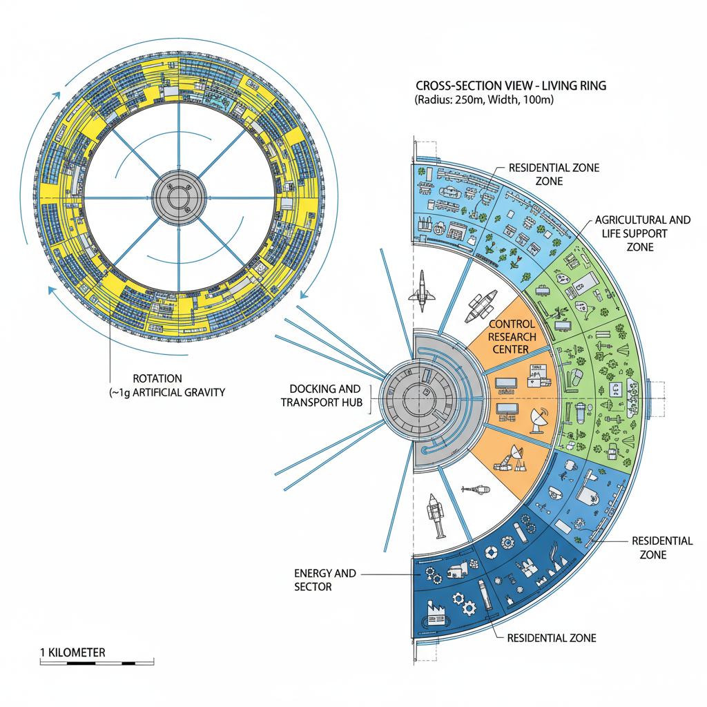

### 

### 4. Orbit and Location

The best location for our colony is the L5-L4 points. These points mean: Points L4 and L5 are two of five special positions in space known as Lagrange points, named after the 18th-century mathematician Joseph-Louis Lagrange.Lagrange points are locations where the gravitational forces of two large bodies—in this case, the Earth and the Moon—and the centrifugal force experienced by a smaller object in orbit combine in such a way that the smaller object can remain in a stable position relative to both larger bodies.

4.1. Key features of this points

4.1.1. Gravitational stability and orbital mechanics

Points L4 and L5 are two of five positions in the Earth-Moon system where the combined gravitational forces of the Earth and Moon, together with the orbital motion of an object, create an area of equilibrium.At these points, a colony can orbit the Sun in synchronisation with the Earth and the Moon, maintaining a relatively fixed position with minimal fuel consumption for positional control

4.1.2. Sustainable and reliable solar energy

L4 and L5 are located about 60 degrees ahead and behind the Moon in its orbit. Of these convenient points, the colony will be under constant sunlight for most of the year.

This ensures continuous solar energy production without long blackout periods.Thermostability, because temperature cycles are predictable, ideal conditions for photosynthetic life support systems and renewable energy infrastructure.

4.2. Orbit short characteristics

* Distance from Earth: approximately 384,000 km
* Orbital period: Same as the Moon’s (≈27.3 days)
* Sunlight exposure: 100% (no eclipses by Earth or Moon)  
  Gravity environment: Microgravity (almost zero g)
* Station-keeping: Minimal thrust required — can be done with low-power ion engines or solar sails
* Thermal stability: Predictable and manageable with radiators and shades

In this orbit, the colony will move in synchrony with both the Moon and the Earth, effectively “sharing” their orbit around the Sun.

### 5. Resource Extraction Plan

5.1. Oxygen

The production of oxygen on the space station is managed by the Russian system “Elektron-VM,” which was developed by NIIKhimmash. It has been operating on the ISS since the very first day of its existence and produces oxygen through the electrolysis of water.

In general, the system works quite simply: water is fed into a special tank, and an electric current is passed through it, causing the liquid to split into molecules of oxygen and hydrogen.

In one hour of operation, the system can produce up to 160 liters of oxygen and 320 liters of hydrogen. To provide one person with a daily supply of oxygen, about one liter of water is required. The oxygen produced meets all medical standards, making it completely safe for humans and suitable for use on board.

As for the hydrogen, it is currently released into open space, but in the future, scientists hope to find useful applications for it as well.

5.2. Water

One of the most reliable systems developed by JSC "NIIKhimmash" is the Water Recovery System from Atmospheric Condensate (SRV-K2M), which was first used aboard the Salyut-4 orbital space station.

The system provides over 50% of water return into the consumption cycle. It is rightfully considered the best in the world in terms of specific equipment mass per kilogram of recovered water and average daily power consumption per astronaut.

Moreover, there is equipment capable of extracting water from human waste, meaning that urine can be purified and reused to replenish the station’s water supply. According to calculations, each ISS crew member produces up to 2.5 liters of liquid per day.

### 6. Population and Society

A stable and self-sustaining population is one of the most essential components of any long-term space colony.

Demography directly influences the colony’s biological stability, social structure, and environmental balance. The number of inhabitants must be carefully selected to ensure both genetic diversity and efficient resource management while maintaining sustainable living conditions inside a closed ecological system.

## Population and Demographic Overview

### 6.1. Total Population and Structure

The colony’s population is designed for 120000 inhabitants, ensuring an optimal balance between genetic diversity, social stability, and environmental capacity.

Men will make up 60% (72000) and women 40% (≈48000), providing both workforce balance and reproductive potential.

### 6.2. Reproductive Viability and Age Distribution

About 70% of the population (84000 people) will be of reproductive age, ensuring long-term population renewal.

Average age ranges: men 21–40, women 20–36.

A controlled fertility rate of 1.8–2.1 children per woman maintains stable growth aligned with resource capacity.

### 6.3. Generational and Genetic Stability

Each generation (~25 years) should remain roughly equal in size to preserve resource balance.

Genetic health monitoring and controlled reproduction programs prevent inbreeding.

If needed, small migration waves from Earth will refresh genetic diversity.

Studies by NASA and ESA show that a minimum viable population is 20,000–25,000; thus, 40,000 ensures long-term survival and redundancy.

### 6.4. Occupational Distribution

To sustain all vital functions:

* 30% – Engineering, construction, maintenance
* 25% – Science, research, medicine
* 20% – Agriculture and life-support
* 15% – Governance, education, communication
* 10% – Security, transport, services

### 6.5. Environmental and Ecological Balance

Each inhabitant requires 25–30 m² of agricultural area via hydroponic/aeroponic systems.

The total life-support area is about 1.2–1.5 million m², sustaining the O₂–CO₂–H₂O cycle.

Each person produces 1 kg of CO₂ and needs 0.84 kg of O₂ daily, making environmental regulation critical for stability.

6.6. Graphic of population growth

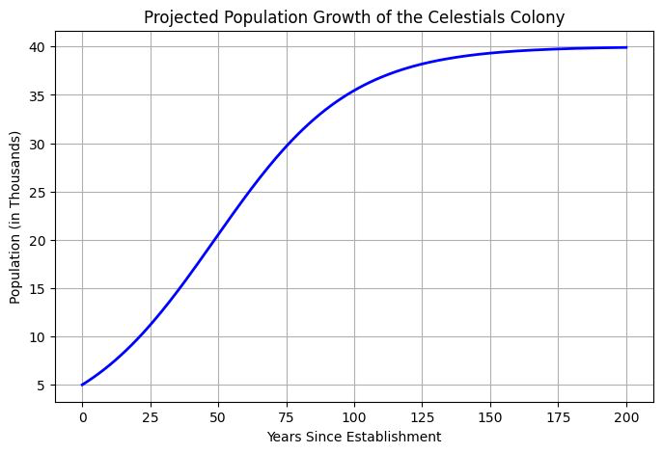

6.7. Cyborgs

Human biology is not fully adapted to space conditions — radiation, microgravity, and limited resources pose severe risks.

To ensure survival and efficiency, humans must be modernized into cyborgs — a fusion of biological and technological systems.

### 6.7.1. Core Concept

The main goal is to preserve human consciousness while replacing or enhancing the body with synthetic components.

Essential organs such as the brain, nervous system, heart, and reproductive system remain organic.

Other systems — muscles, lungs, bones, and circulation — become artificial and optimized for space environments.

### Functional Improvements

### Cyborg bodies will feature:

* Radiation-resistant skin and tissues
* Artificial lungs that recycle and purify air
* Nano-fluid circulatory system instead of blood for better oxygen delivery
* Enhanced muscles with higher strength and endurance
* Multispectral vision and improved environmental awareness

### 6.7.2. Long-Term Vision

Cyborg humans will be capable of:

* Surviving deep-space radiation
* Living for centuries with minimal maintenance
* Operating independently from fragile life-support systems

This transformation marks the next step of human evolution — a species designed to live and thrive beyond Earth.

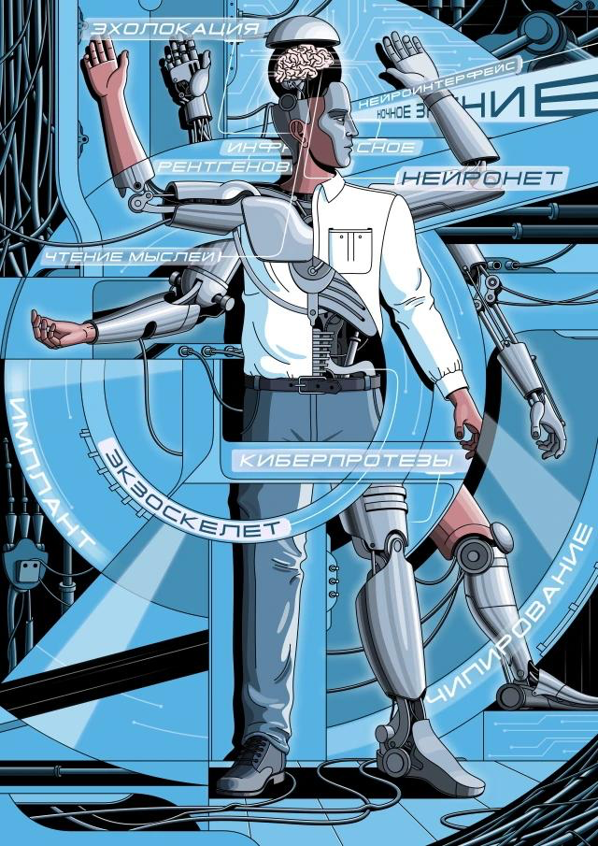

### 7. Technology and Systems

Robotic Systems

To ensure the autonomous and continuous operation of the toroidal space station, three main types of robots are implemented, each designed for specific functional zones and technical tasks.

### 7.1. AURIS : Autonomous Utility & Repair Intelligent System

Type: Service and maintenance robot (internal operations)

Purpose:Performs maintenance of life support systems, minor repairs, and internal inspections.

Features:Equipped with multi-functional manipulator arms with built-in tools.

Uses cameras and LiDAR for precise 3D indoor navigation.  
Can replace filters, connect cables, and seal micro-leaks autonomously.

Charges at docking stations integrated into the walls.

Appearance:

A compact humanoid or tracked module with blue light indicators and a single camera “eye.”

### 7.2. ARACHNOS Autonomous Robotic Assembler for Construction in Orbit

Type: Construction and external repair robot (outer surface operations)

Purpose:Responsible for assembling and maintaining the station’s outer shell in open space.

Features:Six leg-like manipulators with magnetic grips for movement across the hull.

Integrated tools for welding, panel installation, and structural inspection.

Resistant to radiation and extreme temperatures.

Operates cooperatively in swarms with other ARACHNOS units.

Appearance:A metallic spider-like structure with multiple sensors and built-in floodlights.

### 7.3. VERDANT Vegetation and Environmental Regulation Droid for Agriculture and Nutrition Tasks

Type: Agricultural robot (farming and life-support sector)

Purpose:Monitors and manages the colony’s hydroponic farms, nutrient systems, and environmental balance.

Features:Equipped with sensors for humidity, temperature, CO₂, and light levels.

Soft manipulators for planting and harvesting crops.

Uses an AI model to predict plant growth and optimize environmental conditions.

Communicates with the life-support network to regulate oxygen production.  
Appearance: A low cylindrical robot with two flexible arms, green lighting, and a touch control panel on its body.

7.4. Prototypes of robots

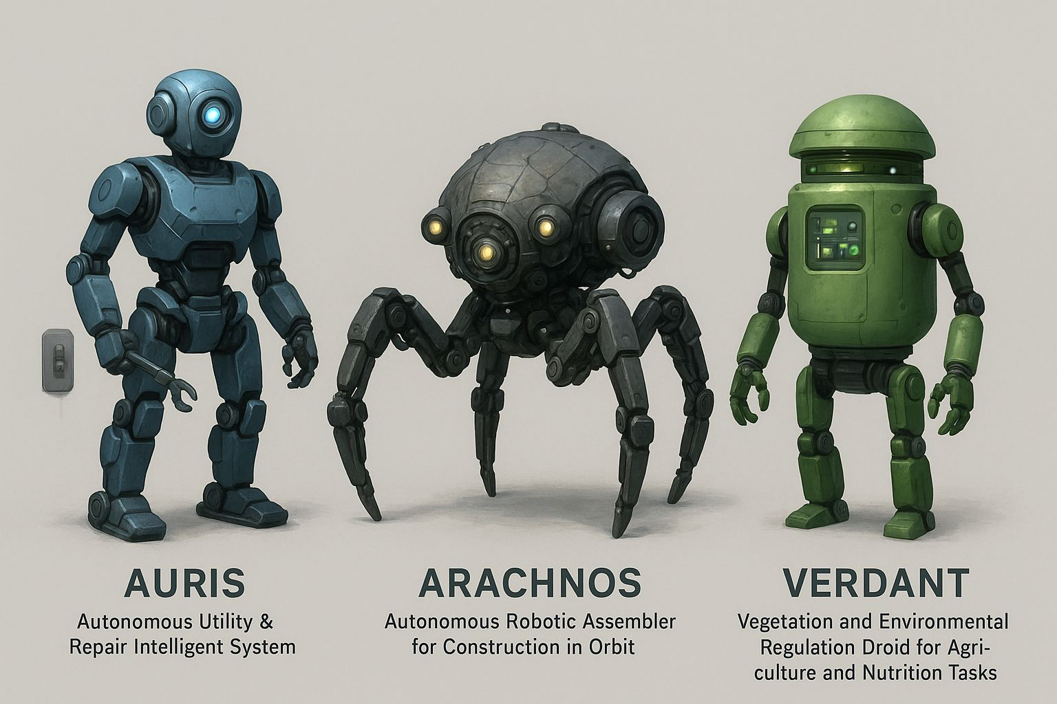

### 8. Sustainability and Longevity

Sustainability and longevity are essential for the success of future space colonization. To survive far from Earth, humans must create systems that reuse resources, minimize waste, and protect both space and planetary environments.

Waste Reduction:  
According to the European Space Agency (ESA), over 54,000 large objects and more than one million smaller fragments orbit Earth. Space debris threatens spacecraft and future missions, so developing technologies that reduce waste and remove defunct satellites is vital to prevent the Kessler syndrome (ESA, 2025).

Resource Usage:  
Transporting materials from Earth is extremely expensive. NASA’s In-Situ Resource Utilization (ISRU) concept promotes using local materials—such as Martian ice, regolith, and CO₂—to produce water, fuel, and oxygen for colonies. This approach increases autonomy and reduces costs (NASA, 2024).

Preservation of Space Environment:  
Rocket launches release soot and aluminum oxide into the upper atmosphere, which can harm the ozone layer and contribute to global warming. Scientists estimate around 1,000 tons of black carbon are emitted yearly from rocket launches (Phys.org, 2022). Developing cleaner propulsion systems and reusable rockets will help minimize this impact.

Space Ethics:  
As humanity expands beyond Earth, fair resource use, conflict prevention, and environmental protection become moral priorities. An international legal framework is needed to ensure that outer space remains peaceful and sustainable for all nations.

Space Economy:  
According to the World Economic Forum (2024), the global space economy now exceeds $550 billion. Expanding industries such as satellite services, resource extraction, and space manufacturing can create jobs and support continuous development, making colonization economically sustainable.

9. Space Safety System Overview

The settlement is protected through layered defense: early detection, avoidance, shielding, and emergency response.

9.1. Detection and Tracking

Continuous monitoring using optical, infrared, and radar sensors combined with global space surveillance data. Automated software predicts collision risks and issues alerts.

9.2. Collision Avoidance

Small thrusters provide controlled maneuvers to change orbit or orientation when a threat is detected. Maintain fuel reserves for emergency course corrections.

9.3. Physical Protection

The outer ring and key modules are covered with multi-layer Whipple shields to absorb micrometeoroid impacts. Life-support and power systems are reinforced and duplicated.

### 10. Conclusion

The proposed autonomous space colony represents a scientifically grounded and technologically achievable vision for the long-term expansion of human civilization beyond Earth.

Through the combination of advanced life-support systems, controlled population management, and post-human biological adaptation, the colony ensures both environmental balance and societal stability for generations to come.

By integrating cybernetic enhancement with human intelligence, the project removes the biological limitations that have historically restricted space colonization.

Its strategic placement in a stable Lagrange Point (L4 or L5) orbit guarantees consistent energy access, minimal gravitational instability, and safe distance from harmful cosmic radiation.

This model demonstrates that the fusion of biology, engineering, and artificial intelligence can create a self-sustaining, independent society capable of thriving without external support.

The colony stands as a prototype for the next stage of human evolution — a civilization designed not only to survive in space but to expand, innovate, and lead humanity toward a truly interstellar future.

11. Bibliography

Information about probability and future drawbacks <https://www.bbc.com/future/article/20141002-time-to-plan-a-space-colony>

Information about concept of colony and 3D prototype

<https://www.techinsider.ru/technologies/323162-10-shagov-k-uspeshnoy-kolonizatsii-kosmosa/>

General information about space and its features

<https://naked-science.ru/article/cosmonautics/kolonizatsiya-kosmosa-tserera-mars-ili-tsilindry-klarka/amp>

AI was also involved in correcting texts mistakes and make official based texts(Gemini,Perplexity,Open Ai)

Information about population management

<https://www.quora.com/How-many-people-would-need-to-be-included-on-a-deep-space-colonizing-mission-in-order-to-maintain-or-rebuild-quickly-a-semblance-of-life-on-earth-Genetically-scientifically-technologically-diversity-allowing-us-to>

Carl Sagan’s literacy’s called Cosmos

<https://cosmicperspective.com/carl-sagan-cosmos/>